UNIT 3
Lesson 5 – WHAT'S THE TIME?
- 1 What is the time now?
Koliko je sati sada?
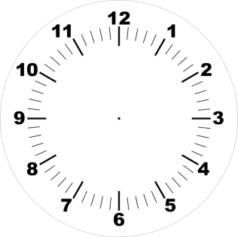
a) Look at the different times. Finish the sentences.
Pogledaj različita vremena. Dovrši rečenice.
Sjeti se: izraz o'clock koristimo za puni sat.

9:00
1 It is nine (9) O'CLOCK.
Devet je sati.
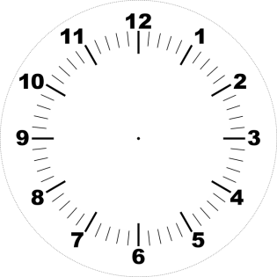
2 It is five (5) _______ .
5:00
Pet je sati.

3:00
3 It is three (3) _______ .
Tri je sata.

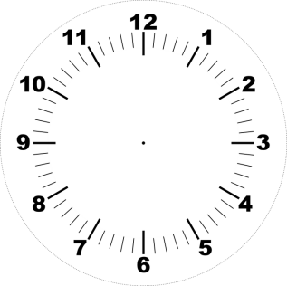
11:00
4 It is eleven (11) ________ .
Jedanaest je sati.

b) Look at the different times. Complete the sentences.
Pogledaj različita vremena. Nadopuni rečenice.
Sjeti se: izraz half past koristimo za pola sata (30 minuta).

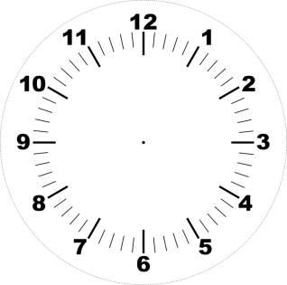
1 It is HALF PAST five (5).
5:30
Pet je sati i trideset minuta.

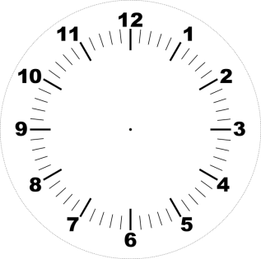
2 It is ____ _____ two (2).
2:30
Dva su sata i trideset minuta.
7:30
3 It is ____ _____ seven (7).
Sedam je sati i trideset minuta.

10:30
4 It is ____ _____ ten (10).
Deset je sati i trideset minuta.

c) What is the time? Circle the correct answer.
Koliko je sati? Zaokruži točan odgovor.
8:00
1 A It is half past eight.
B It is eight o'clock.
9:30
2 A It is half past nine.
B It is nine o'clock.
3 A It is half past six.
6:30
B It is six o'clock.
4 A It is half past one.
1:00
B It is one o'clock.
- 2 a) Look at the different times.
Complete the sentences. Pogledaj različita vremena. Dovrši rečenice.
Sjeti se: izraz a quarter past koristimo za 15 minuta iza punog sata.

10:15
1 It is A QUARTER PAST ten (10).
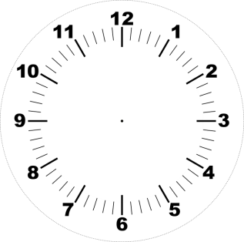
Deset je sati i petnaest minuta.
8:15
2 It is _ ________ ____ eight (8).
Osam je sati i petnaest minuta.
6:15
3 It is _ ________ ____ six (6).
Šest je sati i petnaest minuta.
5:15
4 It is _ ________ ____ five (5).
Pet je sati i petnaest minuta.

b) Look at the different times. Complete the sentences. Pogledaj različita vremena. Dovrši rečenice.
Sjeti se: izraz a quarter to koristimo za 15 minuta do sljedećeg punog sata.

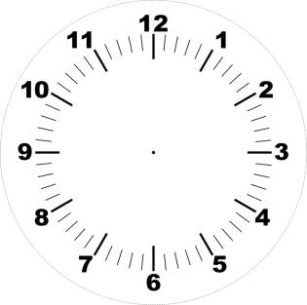
10:45
1 It is A QUARTER TO eleven (11).
Petnaest do jedanaest.
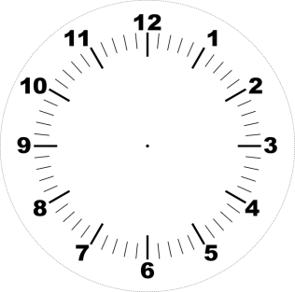
7:45
2 It is _ ________ ____ eight (8).
Petnaest do osam.
5:45
3 It is _ ________ ____ six (6).
Petnaest do šest.
4:45
4 It is _ ________ ____ five (5).
Petnaest do pet.

c) What is the time? Circle the correct answer.
Koliko je sati? Zaokruži točan odgovor.
9:15
1 A It is a quarter past nine.
B It is a quarter to nine.
9:45
2 A It is a quarter past nine.
B It is a quarter to ten.

3 A It is a quarter past six.
6:15
B It is a quarter to six.
3:45
4 A It is a quarter past three.
B It is a quarter to four.

- 3 What is the time? Match the times to the clocks.
Koliko je sati? Spari vremena (rečenice) sa satovima.

a) It is twelve o'clock.
Dvanaest je sati.

b) It is a quarter past five. Pet je sati i petnaest minuta.

c) It is half past two.
Dva su sata i trideset minuta.

d) It is a quarter to six.
Petnaest do šest je.

e) It is a quarter to four. Petnaest do četiri.

3:45
1

2
2:30

12:00
3
5:45
4
5:15
5

- 4 a) Listen to track 3.6. Who is talking?
Circle the correct person.
Poslušaj zvučnu snimku 3.6. Tko priča? Zaokruži točnu osobu.
1  2  3
Penelope Sophie Tia

b) What is Tia's daily routine? Read the sentences.
Circle YES for true and NO for false sentences.
Kako izgleda Tijina svakodnevica? Pročitaj rečenice.
Zaokruži YES (DA) za točne rečenice i NO (NE) za netočne rečenice.
1 First she gets up.  YES / NO
Ona prvo ustaje.
2 She washes her face.  YES / NO
Ona se umiva.
3 She gets dressed. 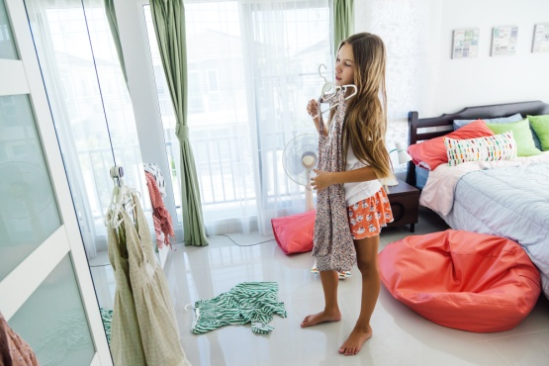 YES / NO
Ona se oblači.
2 She walks the dog.  YES / NO
Ona šeta psa.

3 She takes a taxi to school.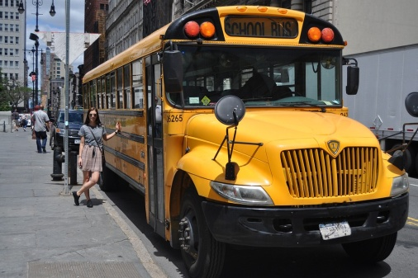 YES / NO
Taksijem putuje u školu.
4 She has lunch.  YES / NO
Ona ruča.
5 She goes home after school. 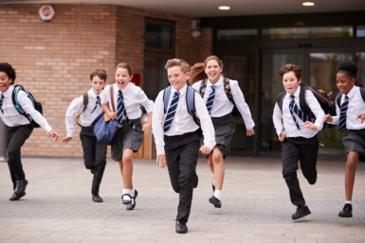 YES / NO
Poslije škole ide kući.
6 She watches TV.  YES / NO
Ona gleda televiziju.
7 She goes to the shop.  YES / NO
Odlazi u trgovinu.

c) Listen to track 3.6 once again and match the beginings with the endings in task 4 b). Check with your classmate.
Poslušaj snimku 3.6 još jednom. Pokušaj spariti početak s krajem rečenice tako da bude točna. Provjeri točnost rješenja s prijateljem iz klupe.
* Ako učenik slabije prati zvučni zapis, tekst govori učitelj.
1 She gets up, washes
and gets dressed __ at seven o'clock (7.00)
in the evening.
2 She has breakfast __ at nine o’clock (9.00).
3 She takes a bus 1 at seven o’clock (7.00).
4 School starts __ at half past seven (7.30).
5 She has lunch __ at eight o'clock (8.00).
6 School finishes __ at half past twelve (12.30).
7 She gets home __ at half past three (3.30).
8 She has dinner __ at a quarter past four (4.15).
9 She goes to bed __ at around eleven o'clock (11.00).
d) Tia does some things in the morning, in the afternoon
and in the evening.
Tia različite stvari obavlja ujutro, popodne i navečer.
She gets up at 7.00 o'clock in the morning. This is 7 a.m.
Ustaje u 7 sati ujutro. To se kaže: 7 a.m.
She has dinner at 7.00 o'clock in the evening. This is 7 p.m.
Večera u 7 sati navečer. To se kaže: 7 p.m.
a.m. = in the morning (ujutro)
p.m. = in the afternoon / evening (popodne / navečer)

Can you tell what the time is, a.m. or p.m.?
Circle the correct time.
Možeš li razlikovati izraze a.m. i p.m.?
Zaokruži točan odgovor pored vremenskog izraza.
8 in the morning 8 a.m. / 8 p.m.
11 in the evening 11 a.m. / 11 p.m.
3 in the afternoon 3 a.m. / 3 p.m.
9 in the morning 9 a.m. / 9 p.m.

e) How does your daily routine look like?
Kako izgleda tvoja svakodnevica?
1 When do you get up?
Kada ustaješ?
I get up at ______________________________ .
(Ustajem u …sati.)
2 When yo you start school?
Kada ti počinje škola?
School starts at ______________________________ . (Škola počinje u … sati.)
3 When do you have lunch?
Kada imaš ručak?
I have luch at __________________________________ . (Ručam u … sati.)

4 When do you go to bed?
Kada ideš u krevet na spavanje?
I go to bed ___________________________________.
(Idem na spavanje u …sati.)

- 5 a) Look at the pictures. What are the poeple doing?
Talk to your classmate.
Pogledaj slike. Što ljudi na njima rade.
Povedi razgovor sa svojim prijateljem iz klupe.
b) Read the words that describe them.
Pročitaj riječi koje opisuju slike.

c) Try to order the pictures so they show a daily routine.
Start with morning activities and move on to evening ones.
Write the numbers from 1 – 7 in the empty frames.
Pokušaj posložiti slike redom kako se one dešavaju u danu.
Upiši brojeve (od 1 do 7) u prazne okvire.



1

make dinner have a shower wake up


go to bed get dressed
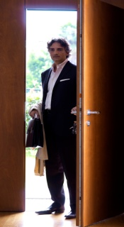

go to work get home

d) Discuss your answers with a group.
Provjeri svoje odgovore u grupi.
e) Listen to Mrs Walker's daily routine (track 3.7).
Poslušaj audio snimku 3.7 iz udžbenika u kojoj gospođa Walker
opisuje svoju dnevnu rutinu.

f) This is what Mrs Walker's day look like .
Read the sentences with a help of your teacher.
Ovako izgleda dan u životu gospođe Walker.
Pročitaj sažetak uz pomoć učitelja / učiteljice.



1 Mrs Walker first gets up.
Gopođa Walker prvo ustaje.

2 Then she wakes up Tia.

Onda budi Tiju .

3 Mrs Walker then has a shower and gets dressed.
Gospođa Walker se tušira i oblači.

4 She goes to work.
Ona odlazi na posao.

5 Work finishes in the evening.
S poslom završava navečer.

6 She gets home soon.
Ubrzo nakon posla stiže kući.

7 She makes dinner for her family.
Ona sprema večeru za svoju obitelj.

8 Mrs Walker goes to bed around midnight.
Gospođa Walker ide na spavanje oko ponoći.

- 8 a) Does Mrs Walker's day look like the one in task 5 b)?
Podsjeća li dan gospođe Walker na rutinu koju si uredio/ uredila u 5 b) zadatku?
b) Listen to track 3.7 once again.
Concentrate on the times. Circle the correct times.
Check your answers with you learning partner.
Poslušaj zvučnu snimku 3.7. ponovno.
Usmjeri pažnju na vremena kada se radnja zbiva.
Zaokruži točno vrijeme.
Provjeri svoje odgovore sa svojim prijateljem iz klupe.
* Ako učenik slabije prati zvučni zapis, tekst govori učitelj.

1 Mrs Walker gets up at six ( 6.00) / half past six (6.30).

2 She wakes up Tia at half past seven ( 7.30) / seven (7.00).

3 Then Mrs Walker has a shower and gets dressed.

4 She goes to work on the subway
at ten minutes past eight (8.10) / ten minutes to eight (7.50).

5 Work finishes at five o'clock (5.00) / six o'clock (6.00) in the evening.
Tia's mum gets home at
twenty minutes past five (5.20) / twenty minutes to six (5.40) .

6 She makes dinner for her family.

7 Mrs Walker goes to bed around midnight.

- 9 Work out your daily routine.
What happens first, next and last in your day?
Draw or glue the pictures in the empty frames.
Write the hours of your daily acitvities.
Razmisli o svojem danu. Što radiš prvo, sljedeće, a što posljednje u danu? Nacrtaj ili zalijepi sličice u prazne okvire.
Napiši vremena kada se zbivaju te radnje.

1  time: | 2  time: | 3  time:
4  time: | 5  time: | 6  time:
7  time: | 8  time: | 9  time:

 | 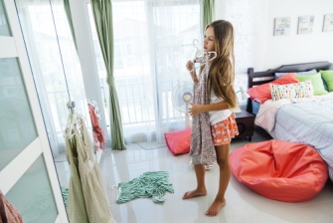 | 
 | 